Pre-Discovery Preparation
This document is meant to serve as a guide to Five9 customers in preparation for the Discovery meeting where requirements gathering will take place. Discovery questions and requirements should not be limited to this document

General Questions
- Describe your company’s business.
  - Bob Barker Company is known as the leading supplier of products and supplies for correctional and secure institutional environments. We provide a wide range of goods designed for jails, prisons, juvenile centers, mental health facilities, homeless shelters, and similar institutions.
- Describe the business conducted through the call center.
  - Customers get help ordering products or solving issues. The team answers questions about products, checks on orders, helps with returns, and guides customers on what supplies they might need.
- Describe your current call center operations.
  - The call center acts as the main point of contact for customers. Right now, it handles incoming calls, emails, and chats. Helping customers with placing orders, tracking shipments, processing returns, and answering questions about products. Finance handles incoming calls as well. They help customers with questions regarding taxes, bills, invoices, etc. They also take payments from our customers.
- What type of call are the agents processing? Inbound, Outbound or Blended? Inbound; Outbound is Reactive
  - Placing Orders
  - Tracking Orders
  - Product questions
  - Credits / Returns or issues with shipments
  - Requesting quotes
  - Requesting Invoices
  - Requesting Packing Slips
  - Assisting Account Managers
  - Invoice questions
  - Tax issues
  - Bill payments

- Other
  - Describe the Agent Distribution.
    - Customer Service
      - 3 Team Leads
      - 3 Sr Customer Reps
      - 1 Expeditor
    - 5 Customer Service Reps
    - Finance
      - 1 Team lead
      - 3 Agents
  - How do you measure the success of your call center?
    - KPI’s
      - Abandoned Rate
      - Incident Rate
      - Actions Per Hour
      - Average Handle Time
      - NPS-Customer Satisfaction
      - Quote Turn Around Time

  - What monthly call volume should we anticipate for inbound and/or outbound?
    - Approx 1,520 inbound calls a month in CS
    - Approx 410 inbound calls a month in Finance
    - Outbound is reactive only

    - What are your call center hours of operation? Monday through Friday 8:00 AM EST-7:00 PM EST

    - Do you have a need for 24x7?
      - No
    - What hours of the day is your IVR running?
      - We don’t currently have one
  - How do you handle after hour and holiday closures?
    - When the call center is closed, customers hear a recorded message and have the option to leave a voicemail. They can also submit a case through webchat or log in to their account on the website.

General Requirements for configuration
- User list containing user name, first and last name, email address, and one or more roles (Administrator, Supervisor, Agent, Reporting)
  - Attached to the email.
- Default ANI which is the number to appear in the caller ID display for outbound calls from your Five9 domain.
  - 1-800-334-9880 for CS
  - 1-800-235-8586 for Finance

- List of Data fields to be gathered on the call
  - Customer Name
  - Customer Phone Number
  - Customer Ship to address
  - Customer Ship to address
  - Customer Code
  - Item codes
  - Item qty.

- Will this be housed in an external CRM or in Five9?
  - We use NetSuite and want to integrate Five9
- If external CRM, please prepare to demo how you utilize this tool.
  - We use NetSuite and want to integrate Five9

- List of Dispositions
  - A disposition is used by agents to set the result of a call. Dispositions appear in reports.
  - For each disposition (primarily for outbound campaigns) indicate redial behavior.
    - Order
    - Quote
    - Where is my order
    - Escalation
    - Service Call
    - Packing Slips
    - Private Management
    - AM Call
    - Finance/CC Pmt
    - NetSuite Concern
    - Other

- List of Skill Groups
  - Skill groups organize user into groups assigned to the call queues that are part of campaigns. Users can be assigned to multiple skill groups; campaigns can have multiple skill groups.
    - Finance
    - Orders
    - Questions

- OPTIONAL: FTP information including FTP hostname, username and password
  - This will be utilized if there is a requirement to archive call recordings and reporting data to your system since Five9 follows a data retention policy
    - We do not use this
    - What is the retention period for Five9

INBOUND Campaign CONFIGURATION
Inbound campaigns are used to receive customer calls coming from a DNIS. The calls are processed according to your rules which will be discussed in more detail during the Discovery Session. The following items outlines the scope of discovery for inbound campaign configuration in Five9. Preparing these information before the Discovery Session will be beneficial to a more effective discussion
- List of inbound campaigns to be configured
  - How many campaigns will be running simultaneously?
    - Two
  - What is the description for each?
    - Customer Service
    - Finance
  - Will agents follow a speaking script for each call?
    - No
- Call Flow process document (Flowchart, diagram, step by step process document, etc)
  - Attached to the email
- When a call is connected to an Agent, what is their workflow?
  - EX: Tasks completed, call handling functions
    - The agent receives the call and sees the customer details
    - They greet the customer professionally
    - Confirm the customer and the account.
    - Identify the purpose of the call and ask clarifying questions.
    - The agent reviews the customer’s account, previous interactions, and relevant data in the system.
    - If the issue can be resolved: The agent provides the solution, walks the customer through steps, or processes the request.
    - If escalation is needed: The agent creates a case
    - The agent confirms the customer is satisfied and asks if they need further assistance
    - They thank the customer and end the call professionally.
    - Pick the correct disposition
    - Complete any after-call tasks
    - The agent logs the call details in Netsuite

- Audio files for IVR prompts and recordings
  - Will you be using TTS (text-to-speech) or custom recorded voice prompts?
    - Custom recorded voice prompts but may go back to text-to-speech
- Call Queue handling process
  - Will calls be queued for X number of minutes?
    - Combo of 18 and 30 seconds
  - Will you offer callbacks while waiting on queue?
    - Yes
  - Will calls be routed to voicemail after X number of minutes?
    - Offer VM after 48 seconds
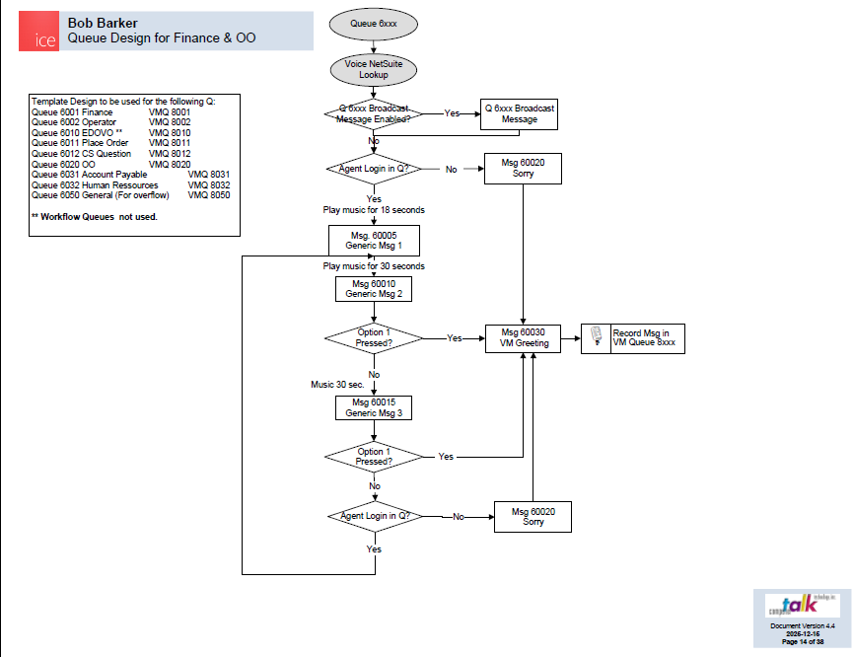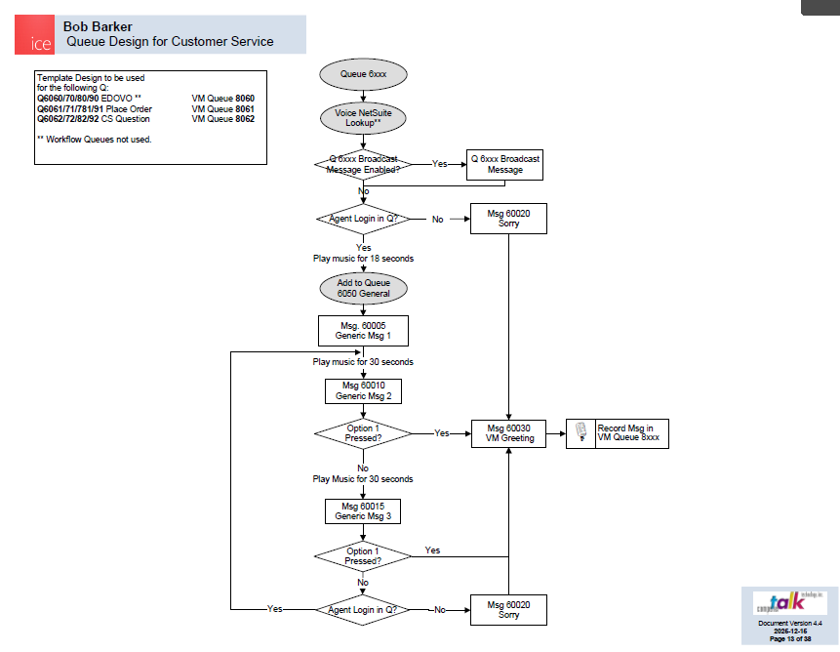

outbound Campaign CONFIGURATION
Outbound Campaigns are used to dial the customers included in the lists and deliver these calls to agents who process calls. Agents do not dial customers in this type of dialing campaign. Dialing can be handled by the Five9 dialer which dials through a list of contacts and delivers connected calls to you.

- List of outbound campaigns to be configured
  - How many campaigns will be running simultaneously?
    - We don't use these. All outbound are reactive to customer needs.
  - What is the description for each?
    - We don't use these. All outbound are reactive to customer needs.
  - Will agents follow a speaking script for each call?
    - No
- Dialing schedule parameters (Is it from 8 AM to 9 PM?)
- Sample list file to be loaded to Five9 for dialing
  - What CRM fields are needed to be created?
  - Where are you getting your list from?
- What dialing mode are you interested in using for outbound campaigns? (Power, preview, progressive, predictive)

